

A Project Report On

**“HOSPITAL MANAGEMENT”**

**Submitted By:**

ABHISHEK KUMAR

Roll No: 23 Class: XII B

**Under the Guidance of**

Mr. Anoop V S

PGT (Computer Science)

Department of Computer Science

**SAINIK SCHOOL KALIKIRI**

**Department of Computer Science**

**SAINIK SCHOOL KALIKIRI**



This is to certify that **Cdt.ABHISHEK KUMAR ,** Roll No. 23 of Class XII has prepared the report on the Project entitled **“HOSPITAL MANAGEMENT”**. The report is the result of his efforts & endeavors. The report is found worthy of acceptance as final project report for the subject Computer Science of Class XII.

Signature Signature

(Internal Examiner) (External Examiner)



**DECLARATION**

I hereby declare that the project work entitled “**HOSPITAL MANAGEMENT**”, submitted to Department of **Computer Science**, SAINIK SCHOOL KALIKIRI is **prepared** **by me**. All the **coding** is the result of my **personal efforts**.

Cdt. ABHISHEK KUMAR

Roll No: 23

Class: XII B

SAINIK SCHOOL KALIKIRI



**ACKNOWLEDGEMENT**

I would like to express a deep sense of thanks & gratitude to my **project guide Mr. Anoop V S** Sir for guiding me immensely through the course of the project. He always evinced keen interest in my work. His constructive advice & **constant motivation** have been responsible for the **successful** completion of this project.

My sincere thanks go to **Lt Col Susheel Kumar Mahapatro SM ,** our **Offg** **Principal** sir, for his co-ordination in extending every **possible support** for the completion of this project.

I also thanks to my **parents** for their **motivation & support**. I must thanks to my **classmates** for their timely help & support for **compilation** of this **project**.

**Last but not the least, I would like to thank all those who had helped directly or indirectly towards the completion of this project.**

Cdt.ABHISHEK KUMAR

Roll No: 23

Class: XII B

SAINIK SCHOOL KALIKIRI

**CONTENTS**

1. Working Description .........................
2. How it Works……………………….
3. Code of the Project ............................
4. Output Screens …..............................
5. Bibliography......................................

**WORKING DESCRIPTION**

This program is designed as an e-HOSPITAL

* It felicitates the user with the flexibility of maintaining all sorts of indexing required in order to maintain records of doctors, medicines, inpatients, out-patients and payments related information.
* It automatically assigns doctors to the patients on the basis of avaiblity of doctor and their class of expertise.
* It also manages salary of doctor and other staff working in the hospital.

**HOW IT WORKS**

* It actually stores all it’s data in a database as table.
* This database is connected to python programming language by using which we can interpret data from database.
* we can alter the data stored in database, we can delete old data and can also add new data to it.
* It displays the required content to user when the concerned commands are called off.

**CODE OF THE PROGRAM**

.

import mysql.connector as conn

from prettytable import PrettyTable

from texttable import Texttable

#from datetime import datetime

#import time,calender

#import csv

global data

from os import system

mydb=conn.connect(host='localhost',

user='root',

password='student',

database='Hospital_Management')

if mydb.cursor:

print('done')

#Function is for entering information into InPatient_Management table

def entryIPM():

sl=input("Enter Slno:")

pn=input("Enter the Patient Name:")

pd=input("Enter Patient_ID:")

se=input("Enter the Sex of the Patient:")

ag=input("Enter the Age of the Patient:")

il=input("Enter the Illness of the Patient:")

cd=input("Enter the Name of the Doctor the Patient is Consulting:")

rn=input("Enter the Room no of the Patient:")

da=input("Enter the Date of Admission of the Patient:")

pa=input("Enter the Payment Amount:")

data=(sl,pn,pd,se,ag,il,cd,rn,da,pa)

sql='insert into InPatient_Management values(%s,%s,%s,%s,%s,%s,%s,%s,%s,%s);'

c=mydb.cursor()

c.execute(sql,data)

mydb.commit()

print("successfully entered....")

system("cls")

#Fuction to show InPatient_Management table

def showIPM():

sql='select * from InPatient_Management;'

c=mydb.cursor()

c.execute(sql)

data=c.fetchall()

system("cls")

t=PrettyTable(['Slno','Patient_Name','Patient_ID','Sex','Age','Illness',

'Consulting_Doctor','Room_No','Date_of_Admission','Payment'])

for i in data:

t.add_row(list(i))

print(t)

#Function is for entering information into OutPatient_Management table

def entryOPM():

sl=input("Enter Slno:")

pn=input("Enter the Patient Name:")

pd=input("Enter Patient_ID:")

se=input("Enter the Sex of the Patient:")

ag=input("Enter the Age of the Patient:")

il=input("Enter the Illness of the Patient:")

dv=input("Enter the Date of Visit of the Patient:")

pa=input("Enter the Payment Amount:")

data=(sl,pn,pd,se,ag,il,dv,pa)

sql='insert into OutPatient_Management values(%s,%s,%s,%s,%s,%s,%s,%s);'

c=mydb.cursor()

c.execute(sql,data)

mydb.commit()

print("successfully entered....")

system("cls")

#Function is to show OutPatient_Management table

def showOPM():

sql='select * from OutPatient_Management;'

c=mydb.cursor()

c.execute(sql)

data=c.fetchall()

system("cls")

t=PrettyTable(['Slno','Patient_Name','Patient_ID','Sex','Age','Illness','Date_of_Visiting',

'Payment'])

for i in data:

t.add_row(list(i))

print(t)

#Function is to enter the information into the Doctor table

def entryDoctor():

sl=input("Enter Slno:")

dn=input("Enter the Doctor Name:")

dd=input("Enter Doctor_ID:")

se=input("Enter the Sex of the Doctor:")

ag=input("Enter the Age of the Doctor:")

da=input("Enter the Department of the Doctor:")

ad=input("Enter the Days on which the Doctor is Available:")

sa=input("Enter the Salary of the Doctor:")

data=(sl,dn,dd,se,ag,da,ad,sa)

sql='insert into Doctor values(%s,%s,%s,%s,%s,%s,%s,%s);'

c=mydb.cursor()

c.execute(sql,data)

mydb.commit()

print("successfully entered....")

system("cls")

#Function to show Doctor table

def showDoctor():

sql='select * from doctor;'

c=mydb.cursor()

c.execute(sql)

data=c.fetchall()

system("cls")

t=PrettyTable(['Slno','Doctor_Name','Doctor_ID','Sex','Age','Department',

'Available_Days','Salary'])

for i in data:

t.add_row(list(i))

print(t)

#Fuction to enter information into pay table

def entrypay():

sl=input("Enter SlNo:")

PID=input("Enter patient ID:")

Pn=input("Enter patient name:")

kat=katta()

ndo,SSC,med,ot,cost=kat

data=(sl,PID,Pn,ndo,SSC,med,ot,cost)

sql='insert into pay values(%s,%s,%s,%s,%s,%s,%s,%s);'

c=mydb.cursor()

c.execute(sql,data)

mydb.commit()

def showpay():

sql='select*from pay;'

c=mydb.cursor()

c.execute(sql)

data=c.fetchall()

system("cls")

t=PrettyTable(['SlNo','Patient_ID','Patient_Name','Room_Rent','Scanning_Bill','Medicine_Charges','Other_Charges','Total_Payments'])

for i in data:

t.add_row(list(i))

print(t)

def entryMed():

sl=input("Enter the SlNo:")

mi=input("Enter medicine ID:")

mn=input("Enter medicine name:")

cost=input("Enter cost of medicine:")

data=(sl,mi,mn,cost)

sql='inset into medicine values(%s,%s,%s,%s);'

c=mydb.cursor()

c.execute(sql,data)

mydb.commit()

def showmed():

sql='select*from medicine;'

c=mydb.cursor()

c.execute(sql)

data=c.fetchall()

system("cls")

t=PrettyTable(['SlNo','Medicine_ID','Medicine_Name','Cost'])

for i in data:

t.add_row(list(i))

print(t)

def freakkan():

med=0

nm=int(input("Enter no. of medicine the patient has taken:"))

l=0

if (l<nm):

mn=int(input("Enter the medicine code:"))

cos=f'select cost from medicine where Medicine_ID = {mn}'

c=mydb.cursor()

c.execute(cos)

zen=c.fetchall()

cos=int(zen[0][0])

med+=cos

l+=1

else:

return med

def katta():

global nd

ad=input("Was the patient admitted (Y/N):")

SC=input("Did the patient undergo scans(Y/N):")

med=freakkan()

cost=0

if (ad.lower() =='y'):

nd=int(input("For how many days was the patient admitted:"))

IC=input("Was the patient in ICU(Y/N):")

if (IC.lower() =='y'):

nc=int(input("For how days was the patient admitted in ICU:"))

nco=nc*3000

nd=nd-nc

ndo=(nd*1500)+nco

cost+=ndo

else:

cost+=0

if (SC=='Y'):

mr=input("Did the patient undergo MRI scan(Y/N):")

ct=input("Did the patient undergo CT scan(Y/N):")

us=input("Did the patient undergo Ultrasound scan(Y/N):")

xr=input("Did the patient take X-Ray(Y/N):")

SSC=0

if (mr.lower() =='y'):

SSC+=9000

if (ct.lower() =='y'):

SSC+=4500

if (us.lower() =='y'):

SSC+=2000

if (xr.lower() =='y'):

SSC+=300

cost+=SSC

ot=int(input("Enter other charges:"))

med = 0

cont=0

cont+=med

ndo=(nd*1500)+nco

SSC=0

data=(ndo,SSC,med,ot,cost)

return data

#__mainfunction__

def main():

system("cls")

while(True):

print("HOSPITAL MANAGEMENT SYSTEM")

print("1:Add patient details")

print("2:Show Inpatient details")

print("3:Add outpatient details")

print("4:Show outpatient details")

print("5:Add doctor details")

print("6:Show doctor details")

print("7:Add payment details")

print("8:Show payment details")

print("9:show medicine")

print("10:Exit")

choice=int(input("\t Please select an above option:"))

if (choice==1):

entryIPM()

elif (choice==2):

showIPM()

elif (choice==3):

entryOPM()

elif (choice==4):

showOPM()

elif (choice==5):

entryDoctor()

elif (choice==6):

showDoctor()

elif (choice==7):

entrypay()

elif (choice==8):

showpay()

elif (choice==9):

showmed()

elif (choice==10):

break

else:

print("Wrong choice...")

main() #Main function call

**OUTPUT SCREENS**

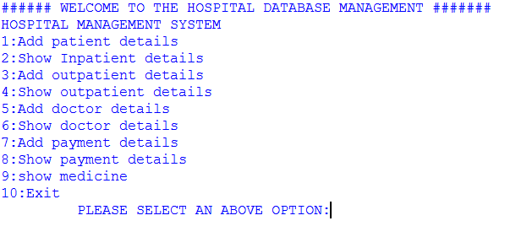

---------------------------------------------------------------------------------------------

---------------------------------------------------------------------------------------------

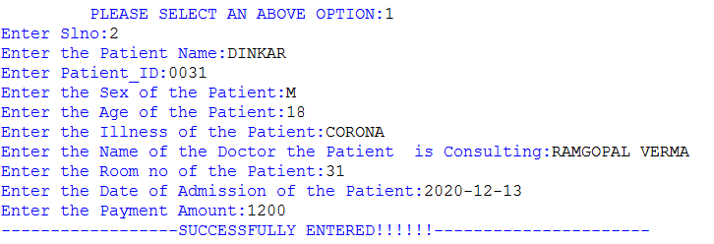

------------------------------------------------------------------------------------------------------------------------------------------------------------------------------------------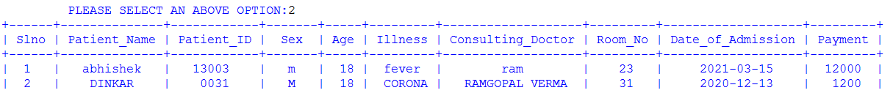

------------------------------------------------------------------------------------------------------------------------------------------------------------------------------------------

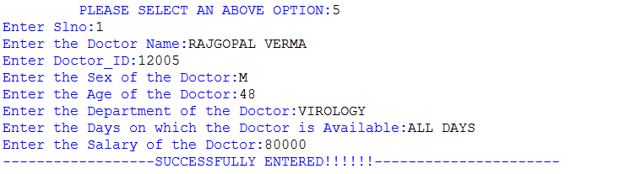

**---------------------------------------------------------**

**4. BIBLIOGRAPHY**

1. Computer Science with Python [Textbook XII] by Sumita Arora

2. https/docs.pyton.org

3. [www.tutorialspoint.com](http://www.tutorialspoint.com)

4. www.geeksforgeeks.org